Modeling and clustering text data

Summary / Observations:

Clustering text data with k-means
- Clustered Wikipedia documents using k-means
- Explored the role of random initialization on the quality of the clustering
- Explored how results differ after changing the number of clusters
- Evaluated clustering, both quantitatively and qualitatively
- When properly executed, clustering uncovers valuable insights from a set of unlabeled documents.
Visualizations:
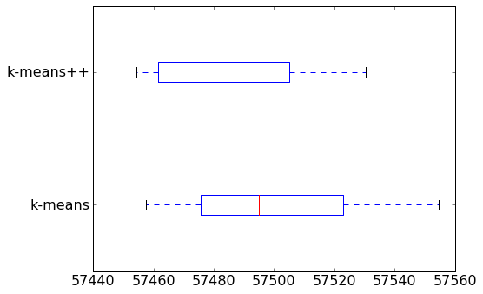
A few things to notice from the box plot:
- On average, k-means++ produces a better clustering than Random initialization.
- Variation in clustering quality is smaller for k-means++.
In general, you should run k-means at least a few times with different initializations and then return the run resulting in the lowest heterogeneity.
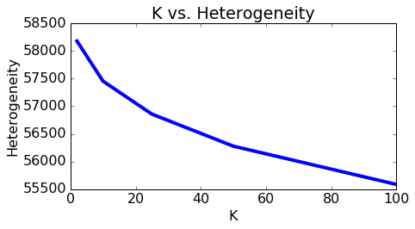
In the above plot we show that heterogeneity goes down as we increase the number of clusters. Does this mean we should always favor a higher K? Not at all! As we will see in the following section, setting K too high may end up separating data points that are actually pretty alike. At the extreme, we can set individual data points to be their own clusters (K=N) and achieve zero heterogeneity, but separating each data point into its own cluster is hardly a desirable outcome. In the following section, we will learn how to detect a K set "too large".
Fitting a mixture of Gaussians using Expectation Maximization Algorithm:
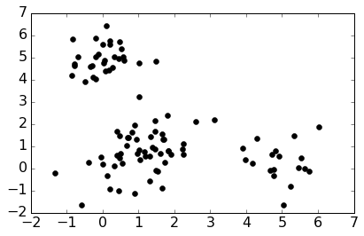
Now we'll fit a mixture of Gaussians to this data using our implementation of the EM algorithm. In this simple case, we'll take three random points to be the initial cluster means, use the empirical covariance of the data to be the initial covariance in each cluster (a clear overestimate), and set the initial mixing weights to be uniform across clusters.
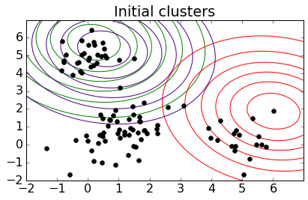
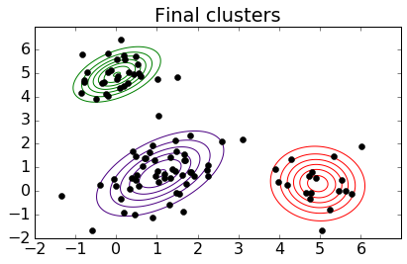
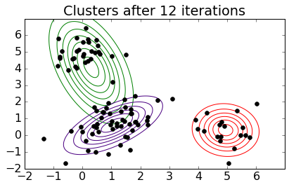
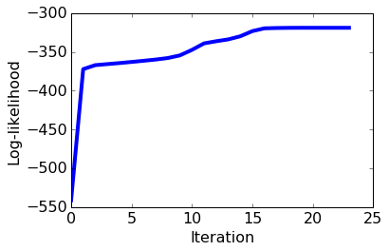
Note: Loglikelihood plot monotonically increasing
Observations:
One weakness of k-means is that it tends to get stuck in a local minimum. To see this, we run k-means multiple times, with different initial centroids created using different random seeds.
Notice the variation in heterogeneity for different initializations. This indicates that k-means sometimes gets stuck at a bad local minimum.
One effective way to counter this tendency is to use k-means++ to provide a smart initialization. This method tries to spread out the initial set of centroids so that they are not too close together. It is known to improve the quality of local optima and lower average runtime.
A few things to notice from the box plot:
On average, k-means++ produces a better clustering than Random initialization.
Variation in clustering quality is smaller for k-means++.
In general, we should run k-means at least a few times with different initializations and then return the run resulting in the lowest heterogeneity.
To Choose k - Since we are measuring the tightness of the clusters, a higher value of K reduces the possible heterogeneity metric by definition. For example, if we have N data points and set K=N clusters, then we could have 0 cluster heterogeneity by setting the N centroids equal to the values of the N data points.
Visualize clusters of documents
What are we looking for in a good clustering of documents?
Documents in the same cluster should be similar.
Documents from different clusters should be less similar.
So, a bad clustering exhibits either of two symptoms:
Documents in a cluster have mixed content.
Documents with similar content are divided up and put into different clusters.
Takeaway: Tiny clusters aren't necessarily bad. A tiny cluster of documents that really look like each other’s is definitely preferable to a medium-sized cluster of documents with mixed content. However, having too few articles in a cluster may cause overfitting by reading too much into a limited pool of training data.

Clustering and measuring similarity:
Document retrieval Task: There are lots and lots of articles out there and we can't expect him to go and read each of them and say yes, he's interested or no, he's not. So, we like to think of a way to automatically retrieve a document that might be of interest to him.
Types of Models for document representation:
Bag of words Model:
Ignore Order of Words
Count No. of Instances of each word in Vocabulary [Count Vector]
To measure similarity: when we think about measuring similarity, what we can do is simply look at an element-wise product over this vector. So, for every element in the vector, we're going to multiply the two elements appearing in these two different count vectors. And add up over all the different elements in this vector.
Discovering similar neighbourhoods –
Task1- Came up with a good estimate of the house in the neighbourhood with few or no sales by leveraging information from this other neighbourhood that was discovered to be related to the current neighbourhood. So, the idea is to discover clusters of neighbourhoods, and then within those clusters we can share information like this house sales information to form better estimates. So, this is the solution that I'm describing here, is to cluster regions with similar trends, and then share information within a cluster.

Task2- Same idea of discovering related regions can be used for helping to forecast violent crimes, to better task police forces to different regions. So again, once we discover different neighbourhoods that have very similar crime dynamics, we can form better predictions of the rates of violent crimes in those neighbourhoods and then use that information to task police to those regions.

ASSIGNMENT 3:

Clustering text data with k-means
In this assignment you will
- Cluster Wikipedia documents using k-means
- Explore the role of random initialization on the quality of the clustering
- Explore how results differ after changing the number of clusters
- Evaluate clustering, both quantitatively and qualitatively
When properly executed, clustering uncovers valuable insights from a set of unlabelled documents.
Write-Up / Pseudo Code:
- Load in the Wikipedia dataset
- Extract TF-IDF matrix
Code:
wiki['tf_idf'] = graphlab.text_analytics.tf_idf(wiki['text'])
Note: For the remainder of the assignment, we will use sparse matrices. Sparse matrices are matrices that have a small number of nonzero entries. A good data structure for sparse matrices would only store the nonzero entries to save space and speed up computation. SciPy provides a highly-optimized library for sparse matrices. Many matrix operations available for NumPy arrays are also available for SciPy sparse matrices.
We first convert the TF-IDF column (in dictionary format) into the SciPy sparse matrix format.
- Normalize all vectors
  - As discussed in the previous assignment, Euclidean distance can be a poor metric of similarity between documents, as it unfairly penalizes long articles. For a reasonable assessment of similarity, we should disregard the length information and use length-agnostic metrics, such as cosine distance.
  - The k-means algorithm does not directly work with cosine distance, so we take an alternative route to remove length information: we normalize all vectors to be unit length. It turns out that Euclidean distance closely mimics cosine distance when all vectors are unit length. In particular, the squared Euclidean distance between any two vectors of length one is directly proportional to their cosine distance.
Let x and y be normalized vectors, i.e. unit vectors, so that ∥x∥=∥y∥=1
- Implement K-Means
  - Let us implement the k-means algorithm. First, we choose an initial set of centroids. A common practice is to choose randomly from the data points.
Note: We specify a seed here, so that everyone gets the same answer. In practice, we highly recommend to use different seeds every time (for instance, by using the current timestamp).

  - Get Initial Centroids(get_initial_centroids(data, k, seed=None)
- After initialization, the k-means algorithm iterates between the following two steps:
  - Assign each data point to the closest centroid.
  - zi←argminj∥μj−xi∥2
  - Revise centroids as the mean of the assigned data points.
  - μj←1nj∑i:zi=jxi

In pseudocode, we iteratively do the following:
cluster_assignment = assign_clusters(data, centroids)
centroids = revise_centroids(data, k, cluster_assignment)

- Assigning clusters

First import pairwise_distances function from scikit-learn, which calculates Euclidean distances between rows of given arrays.
In the k-means algorithm, we will have to compute pairwise distances between the set of centroids and the set of documents.

- Next, given the pairwise distances, we take the minimum of the distances for each data point. Fittingly, NumPy provides an argmin function.

- Produce a 1D array whose i-th entry indicates the centroid that is the closest to the i-th data point. Use the list of distances from the previous checkpoint and save them as distances. The value 0 indicates closeness to the first centroid, 1 indicates closeness to the second centroid, and so forth. Save this array as closest_cluster.

Hint: the resulting array should be as long as the number of data points.

Code:
distances_from_centroids = pairwise_distances(data, centroids, metric='euclidean')
cluster_assignment = np.argmin(distances_from_centroids, axis=1)

- Revising clusters

  - Let's turn to Step 2, where we compute the new centroids given the cluster assignments.

  - SciPy and NumPy arrays allow for filtering via Boolean masks. For instance, we filter all data points that are assigned to cluster 0 by writing
data[cluster_assignment==0,:]
  - In lieu of indices, we can put in the list of Booleans to pick and choose rows. Only the rows that correspond to a True entry will be retained.

  - Given all the data points in a cluster, it only remains to compute the mean. Use np.mean(). By default, the function averages all elements in a 2D array. To compute row-wise or column-wise means, add the axis argument.
Code:
for i in xrange(k):
# Select all data points that belong to cluster i. Fill in the blank (RHS only)
member_data_points = data[cluster_assignment==i]
# Compute the mean of the data points. Fill in the blank (RHS only)
centroid = member_data_points.mean(axis=0)

# Convert numpy.matrix type to numpy.ndarray type
centroid = centroid.A1
new_centroids.append(centroid)
new_centroids = np.array(new_centroids)

Assessing convergence¶
We can look at the cluster assignments and see if they stabilize over time. In fact, we'll be running the algorithm until the cluster assignments stop changing at all. To be extra safe, and to assess the clustering performance, we'll be looking at an additional criteria: the sum of all squared distances between data points and centroids. This is defined as
J(,μ)=∑j=1k∑i:zi=j∥xi−μj∥2.
The smaller the distances, the more homogeneous the clusters are. In other words, we'd like to have "tight" clusters.

for i in xrange(k):

# Select all data points that belong to cluster i. Fill in the blank (RHS only)
member_data_points = data[cluster_assignment==i, :]

if member_data_points.shape[0] > 0: # check if i-th cluster is non-empty
# Compute distances from centroid to data points (RHS only)
distances = pairwise_distances(member_data_points, [centroids[i]],
metric='euclidean')
squared_distances = distances**2
heterogeneity += np.sum(squared_distances)

- Combining into a single function
Once the two k-means steps have been implemented, as well as our heterogeneity metric we wish to monitor, it is only a matter of putting these functions together to write a k-means algorithm that:

  - Repeatedly performs Steps 1 and 2
  - Tracks convergence metrics
  - Stops if either no assignment changed or we reach a certain number of iterations.
This function- kmeans() runs k-means on given data and initial set of centroids.
maxiter: maximum number of iterations to run.
record_heterogeneity: (optional) a list, to store the history of heterogeneity as function of iterations
if None, do not store the history.
verbose: if True, print how many data points changed their cluster labels in each iteration'''
Code:
for itr in xrange(maxiter):
    - Make cluster assignments using nearest centroids
    - Compute a new centroid for each of the k clusters, averaging all data points assigned to that cluster.
    - Check for convergence: if none of the assignments changed, stop
    - Print number of new assignments
    - Record heterogeneity convergence metric
- Plotting convergence metric¶
- Beware of local maxima

One weakness of k-means is that it tends to get stuck in a local minimum. To see this, let us run k-means multiple times, with different initial centroids created using different random seeds.
Note: Again, in practice, you should set different seeds for every run. We give you a list of seeds for this assignment so that everyone gets the same answer.

Findings:

  - Notice the variation in heterogeneity for different initializations. This indicates that k-means sometimes gets stuck at a bad local minimum.

  - One effective way to counter this tendency is to use k-means++ to provide a smart initialization. This method tries to spread out the initial set of centroids so that they are not too close together. It is known to improve the quality of local optima and lower average runtime.

- Write smart_initialize(data, k, seed=None): function
Code:
  - Randomly choose the first centroid.
  - Since we have no prior knowledge, choose uniformly at random
  - Compute distances from the first centroid chosen to all the other data points
  - for i in xrange(1, k):
    - Choose the next centroid randomly, so that the probability for each data point to be chosen is directly proportional to its squared distance from the nearest centroid.
    - Roughtly speaking, a new centroid should be as far as from ohter centroids as possible.
    - Now compute distances from the centroids to all data points
- Compare the set of cluster heterogeneities we got from our 7 restarts of k-means using random initialization compared to the 7 restarts of k-means using k-means++ as a smart initialization.
- Findings:
A few things to notice from the box plot:
  - On average, k-means++ produces a better clustering than Random initialization.
  - Variation in clustering quality is smaller for k-means++.
- In general, you should run k-means at least a few times with different initializations and then return the run resulting in the lowest heterogeneity. Let us write a function that runs k-means multiple times and picks the best run that minimizes heterogeneity.

- How to choose K?
Since we are measuring the tightness of the clusters, a higher value of K reduces the possible heterogeneity metric by definition. For example, if we have N data points and set K=N clusters, then we could have 0 cluster heterogeneity by setting the N centroids equal to the values of the N data points.

- Visualize clusters of documents
Let's start visualizing some clustering results to see if we think the clustering makes sense. We can use such visualizations to help us assess whether we have set K too large or too small for a given application. Following the theme of this course, we will judge whether the clustering makes sense in the context of document analysis.

What are we looking for in a good clustering of documents?
- Documents in the same cluster should be similar.
- Documents from different clusters should be less similar.
So, a bad clustering exhibits either of two symptoms:
- Documents in a cluster have mixed content.
- Documents with similar content are divided up and put into different clusters.
To help visualize the clustering, we do the following:
- Fetch nearest neighbors of each centroid from the set of documents assigned to that cluster. We will consider these documents as being representative of the cluster.
- Print titles and first sentences of those nearest neighbors.
- Print top 5 words that have highest tf-idf weights in each centroid.
- Takeaway
Keep in mind though that tiny clusters aren't necessarily bad. A tiny cluster of documents that really look like each other’s is definitely preferable to a medium-sized cluster of documents with mixed content. However, having too few articles in a cluster may cause overfitting by reading too much into a limited pool of training data.

Clustering and measuring similarity:
Document retrieval Task: There are lots and lots of articles out there and I can't expect him to go and read each of them and say yes, he's interested or no, he's not. So, we like to think of a way to automatically retrieve a document that might be of interest to him.
Types of Models for document representation:
- Bag of words Model:
  - Ignore Order of Words
  - Count No. of Instances of each word in Vocabulary [Count Vector]
  - To measure similarity: when we think about measuring similarity, what we can do is simply look at an element-wise product over this vector. So, for every element in the vector, we're going to multiply the two elements appearing in these two different count vectors. And add up over all the different elements in this vector.
- Word count representation for measuring similarity – Using TF-IDF - what happened when Carlos was reading the shorter documents. So, this doesn't make a lot of sense when we're trying to do document retrieval. And it biases very strongly towards long documents. So, one solution is very straight forward where we're simply going to normalize this vector
- to represent this trade-off between something that's common locally but rare globally is something that's called TF-IDF or Term frequency- inverse document frequency.
- 1- Nearest Neighbour Search Algorithm – Using distance metric
- K-Nearest Neighbour search Algorithm
- Unsupervised Learning Task
  - No Labels are provided.
  - Need to uncover cluster structure
- What defines a cluster?
  - Cluster defined by centre & shape/spread
- K-Means Algorithm
  - Initialize Cluster Centre
  - Assign observations to the closest cluster centre
  - Revise the cluster centres as mean of assigned Observations
  - Iterate the process 1+2 until convergence.
- Other Examples for Clustering:
  - Clustering images – Google image search – It would help if we can structure the images we have by some categories. Very helpful in structured search
  - Grouping patients by Medical Condition
  - Cluster Seizures by observed time courses
  - Discover product categories from purchase histories [Products on Amazon]- In addition to discovering groups of products that are related, that have. Based on purchase histories of these items we can also use that to discover groups of related users on Amazon. And that can be used for targeting products to those users.
  - Structuring web search results. So, for example, search terms can have multiple meanings like the word "cardinal".
  - Discovering similar neighbourhoods –
    - Task1- We can come up with a good estimate of the house in the neighbourhood with few or no sales by leveraging information from this other neighbourhood that was discovered to be related to the current neighbourhood. So, the idea is to discover clusters of neighbourhoods, and then within those clusters we can share information like this house sales information to form better estimates. So, this is the solution that I'm describing here, is to cluster regions with similar trends, and then share information within a cluster.

    - Task2- same idea of discovering related regions can be used for helping to forecast violent crimes, to better task police forces to different regions. So again, once we discover different neighbourhoods that have very similar crime dynamics, we can form better predictions of the rates of violent crimes in those neighbourhoods and then use that information to task police to those regions.

